2021 Milestones: Wayne and Shareboating Achievements
携舟人的2021
携舟出航，自我迭代
“携舟出航”在华洋社会的孕育、深耕与壮大

Prepared by Andrew and Wayne
Edit Charles 22 February 2022
Version 7
Updated on 18 Mar. 2022

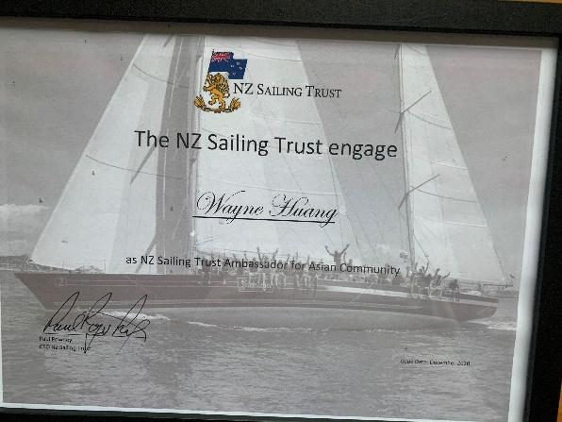
- January 2020. Wayne was appointed the Cultural Ambassador for the NZ Sailing Trust which operates Sir Peter Blake’s legendary round the world yachts Steinlager II and Lion New Zealand. 2020年12月黄伟雄被新西兰帆船基金会聘为新西兰帆船史上绝无仅有的两艘国宝级超级帆船---新西兰雄狮号 (Lion New Zealand) 和斯坦纳格二号 (Steinlager2) 形象大使.这两艘国宝帆船原船主是为新西兰首次夺得美洲杯冠军的彼得·布莱克爵士(Sir Peter Blake.)，黄伟雄成功开启了新西兰国宝级帆船为华商领袖及华人社区的首航.
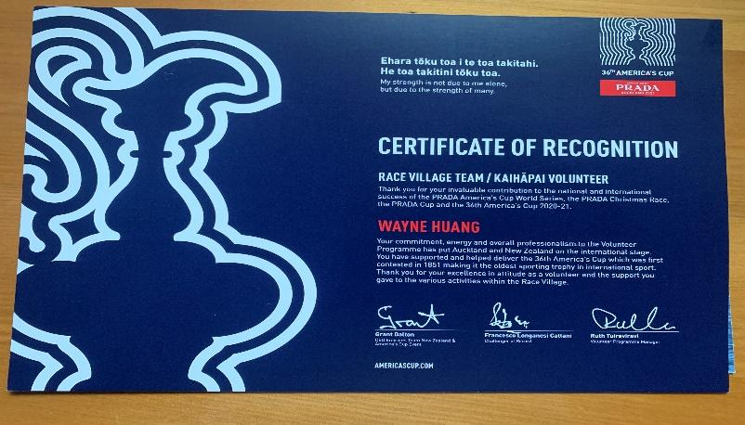
- March, 2021. “Huang a hit during America’s Cup” (Published by The Times, 30 Mar 2021) https://www.times.co.nz/news/huang-a-hit-during-americas-cup/. 在2021年美洲杯帆船大赛期间同步发表出版了28篇原创有关美洲杯的文章，成为当时全球发表该主题最多的作者。并被当地主流英文媒体时代报（Times)广泛报道.
- March. 2021, Wayne worked as a team member for the 36th America’s Cup Village, Auckland 2021 年黄伟雄参与在奥克兰举办的世界四大体育赛事之36届美洲杯帆船赛工作并获得表彰证书.
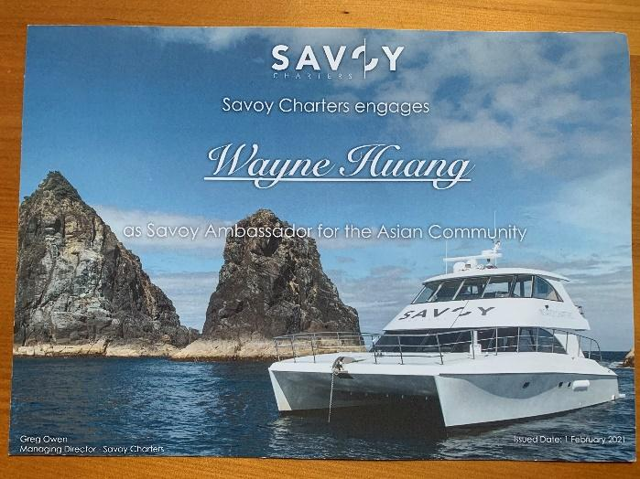
- June, 2021. Wayne was appointed Doc Edge Festival Cultural Ambassador and in partnership with Doc Edge Festival and filmmaker Larry Keating, Wayne and his ShareBoating team delivered groundbreaking results over three weeks (21 May -12 June 2021) preceding the World Premiere 2021年6月黄伟雄受聘为新西兰夺得首次美洲杯大赛冠军Sir Peter Blake 爵士记录片邪恶花园（The Garden of Evil）全球首映式和新西兰记录片形象大使，在黄伟雄的推动下这部纪录片的首映式取得了空前的成功，成为了创历史的最成功案例。这部纪录片由新西兰著名电影制作人、导演拉里·基廷（Larry Keating) 编写、执导。在奥克兰最古老最经典的（The Civic）剧院首映。这部电影生动地再现了新西兰国宝级功勋帆船运动员彼得·布莱克爵士（Sir Peter Blake ）为新西兰赢得历史上首次美洲杯冠军（1995）和在2000年再次成功卫冕，以及其环保的人生旅程, 详见本地主流英文媒体时代报（Time,10 June 2021) . Eastlife Magazine July 2021 期刊和海外华人网和天维网June /2021
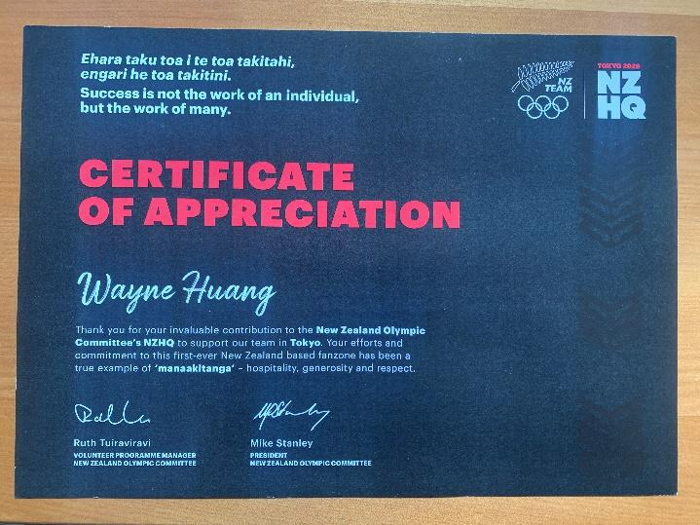
- July, 2021. Wayne worked as a team member for New Zealand Olympic Committee Headquarters in Auckland for the 2020 Toyko Olympic Games年东京奥运会期间，黄伟雄参与了新西兰奥组委在奥克兰总部的工作并获表彰证书.
- July, 2021. Wayne became the first Asian Rear Commodore at Bucklands Beach Yacht Club (BBYC) to be re-elected for a third term. The BBYC is the second largest yacht club in NZ. 2021年黄伟雄第三次获选、连任新西兰第二大游艇会（BBYC）历史上首位华裔常务执行董事、后卫指挥官（Rear Commodore), 至今连任三届.
- August, 2021. During the covid lockdown, Wayne and his team created a huge number of videos for the ShareBoating YouTube channel, inspiring the local Asian community to learn sailing and boating. Upgrading of the second stage on YouTube and Facebook completed on 15 Dec. 2021. 2021年8月奥克兰封城期间，黄伟雄团队创立了携舟出航YouTube 官方平台,中英双语推广新西兰帆船游艇产业。第二期YouTube 和Facebook英文主流社交平台升级工程12月15日完工。
- November, 2021. Wayne was awarded the Yachting New Zealand Service Award in the 2021 New Zealand Yachting Excellence Awards. Wayne has also served as the Vice-Chairman of the Chinese Chamber of Commerce New Zealand for sixteen years. 2021年11月 黄伟雄成为新西兰全国行业最高荣誉《2021年游艇卓越奖》首个获奖华人.
- November, 2021. Wayne was invited to be the inaugural Asian committee member of the Half Moon Bay Marina Berth Owners Association Inc.2021年11月 黄伟雄成为新西兰第二大码头泊位组织之《半月湾码头泊位业主协会》历史上首位华裔常务理事。
- December, 2021. “Service to Yachting Honoured” article with photo published by Eastlife. 2021年12月当地主流英文杂志 (Eastlife )报道. 黄伟雄成为历史上首位华裔赢得新西兰游艇卓越奖 。
In terms of media coverage, Wayne produced 28 America’s Cup related articles published by the most influential local Chinse media in NZ – Skykiwi. Wayne also wrote 15 articles where his commendations were published by the top mainland Chinese media such as Xinhua News Agency and People’s Daily, which elevated Wayne as one most influential overseas Chinese commentators. Local kiwi media also featured Wayne six times during the year as one of the most proactive cross-cultural influencers promoting the New Zealand way of life to the wider community. For more detail, please refer to copy of Wayne’s achievements by media coverage in 2020- 2021
总结2021年媒体与社会影响力，黄伟雄撰写了28篇有关美洲杯帆船大赛的文章在新西兰当地最大中文媒体平台天维网发表，成为当时全球发稿有关美洲杯文章最多的作者。在中国大陆主流媒体方面，有15篇时评被中国最权威的《新华社》，《人民日报》，中宣部《学习強国》釆纳发表，成为海外发稿量最多（新西兰）华人华侨。在新西兰主流英文媒体亦有6篇文章报道。在中外主流舆论场并举，影响力和品牌建设达到无人能匹敌的高度与影响力.
- January 2022. Shareboating team recently makes Whitford Bird Garden and ShareBoating part of Auckland Council funding’s “Explore Tāmaki Makaurau Voucher Programme."
2022年1月， “携舟出航” 和” 惠徳福庄园” 双双被奥克兰市政府列入政府资助参访项目
- February 2022. Shareboating is certified by Auckland Council as a business service provider for Activate Tamaki Makaurau to deliver digital marketing implementation for 40 local business in Auckland
2022年2月，” 携舟出航” 作为奥克兰市政府振兴经济资助企业项目（Moving Auckland business Forward) 授权指定的数字化服务供应商，除了做大做強游艇、游艇会，专业钓鱼船等新西兰游艇业主流行业数字化营销主业外，还利用自身优势与资源，大力从政府部门引资（每个企业$4000），邦扶当地最大华人超市、最大华人社工专业机构，北岸刚完工的最大商业办公楼宇，中餐馆，中医馆，地产中介业数学化市场营销，形势喜人。不龂做大做强 “携舟出航”产业链的“消费大数据”。疫情当下的新常态，“要善于利用逆境”，提升竞争格局，缺口就是风口！把握住政策风口和市场缺口. 携舟出航 ” 不仅做到了第一，还做到了“唯一”

Background in more detail (更多祥细背景资料)
Outstanding Achievements
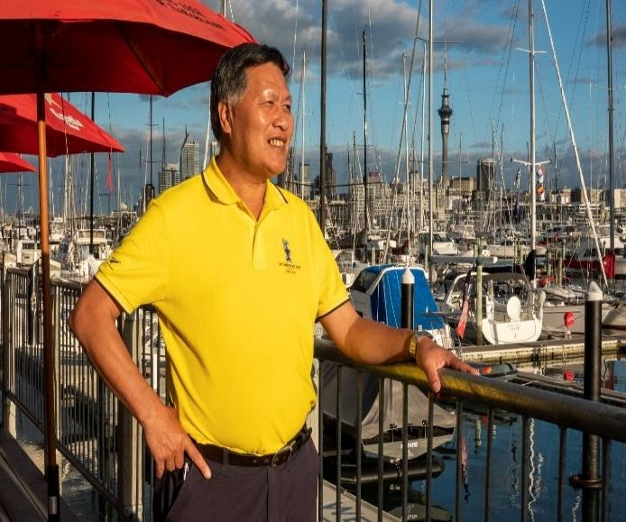
On Chinese social media information evenings Wayne was instrumental in facilitating and promoting Junior Learn to Sail programs to the local community. The uptake was strong and the Junior Learn to Sail program at BBYC became oversubscribed. Wayne was able to translate and explain to parents what the students were doing and take them out in RIBs to see what their children were doing from the water.
Wayne is dedicated to both educating the community about sailing and creating opportunities to access boating, particularly building up grassroots youth sailing. Wayne is also well connected with the business community, with Chinese business networks and understands the variety of opportunities of sailing and boating available to them, eliminating any barriers and making entry level easy.
Wayne is well known for his ability to create and nurture meaningful cross-cultural relationships to ensure that NZ is a great destination for investment, education, and business. This is evident as he is the founder of ShareBoating, which provides and adds value to the marine and yachting industry, attracting local and international participation to these activities. Wayne and Shareboating are partnered with the NZ Sailing Trust to create experiences for new and upcoming markets, especially the Chinese market. Wayne has been appointed as the Cultural Ambassador for the NZ Sailing Trust with the objective to bring young Asian students onto designated youth programs. In addition to getting more youth on the water, the NZST has had a number of open days, business charters, and networking evenings for business clients to communicate the incredible story of what the Trust does. This activity has proven very useful in the wider community and the interest has been strong due to the promotion and sharing on social media, in particular Skykiwi and WeChat.
This activity paved a way for Wayne, a member of RNZYS, to develop several events for the Chinese community during the running of the 36th America’s Cup regatta in Auckland.
Wayne is hugely dedicated to boating, sailing and educating people about sailing, with the ultimatel intention of getting them out on the water. Wayne devotes his personal time to this and has made his passion part of his work. He has achieved all of this in a relatively short timeframe since 2019 and we look forward to seeing what Wayne can achieve for the sport over the next 3 years.
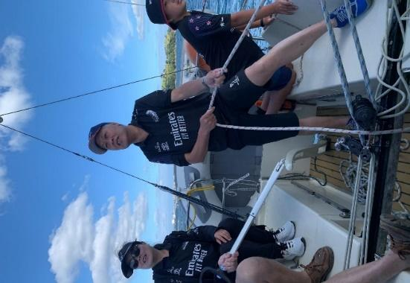
Key Facts
- The first Asian Rear Commodore - Power in New Zealand. Now serving in his third term since 2019..https://www.times.co.nz/news/first-asian-commodore-at-bucklands-beach-yacht-club/

- Played a key role in promoting awareness and participation to the wider community of Junior Learn to Sail courses. Junior Learn to sail programs have reached an historical record high due to participation of Asian students. https://www.yachtingnz.org.nz/news/aon-club-month-bucklands-beach-yc

- Obtained from Fisher and Paykel the engagement and support to sponsor the Bucklands Beach Yacht Club 2021 awards and future events.

- Increased awareness and visitation to the AC36 Cup Village by promoting the 36th America's Cup to the wider community via multiple social media platforms and online media.

- Recognized by Skykiwi, the largest, most influential China media channel in NZ, as the most prolific sports columnist writing over 29 articles for the 36th America's Cup and selected as Skykiwi's sports columnist. https://www.times.co.nz/news/huang-a-hit-during-americas-cup/

- Held a talk show with Skykiwi about sailing and the 36th America's Cup which drew a massive audience of 193,000!

- Initiated the America's Cup NZ Forum for the wider community and facilitated three successful events.

- Volunteered at the Cup Village, Viaduct, Auckland during the 36th America's Cup.

- Volunteered at the NZ Olympic Committee headquarters, at the Cloud, Auckland during the 2020 Olympic Games and contributed photos to the NZ Olympic Committee.

- Appointed Cultural Ambassador by the Doc Edge Festival 2021 and played a role in the success of the World Premiere of The Garden of Evil, a film about Sir Peter Blake, by engaging the Asian community, increasing ticket sales by 20%.

- Appointed Cultural Ambassador by the NZ Sailing Trust, Wayne significantly raised awareness of water and boating experiences in New Zealand by promoting the sailing story of Sir Peter Blake on his round the world winning maxi yacht Steinlager II. https://www.times.co.nz/news/new-kiwis-experience-sailing-for-the-first-time/
- Announced in November 2021 as one of the ten Service Award winners across New Zealand for the 2021 Yachting New Zealand Excellence Awards.
- Yachting NZ named Wayne as one of the winners of a Service Award in their 2021 Excellence Awards.
https://eastlife.co.nz/?fbclid=IwAR2LvYKnZ9xwoZ0-b0ltofd2O2HbF-wXRNjxQ9XsylcWYhNQqEFylWmWy4o

C:\Users\64212\ICENZ Dropbox\Wayne Huang\Sailing NZ Studio 2020 Working Committee\Administration and plan 2020\HR 2020\Year 2021 milestone Wayne 携舟人的2021 version four in New Zealand updated by Dr Charles on 18 Mar. 2022.docx

